**Find the popularity percentage for each user on Meta/Facebook. The popularity percentage is defined as the total number of friends the user has divided by the total number of users on the platform, then converted into a percentage by multiplying by 100. Output each user along with their popularity percentage. Order records in ascending order by user id. The 'user1' and 'user2' column are pairs of friends.**

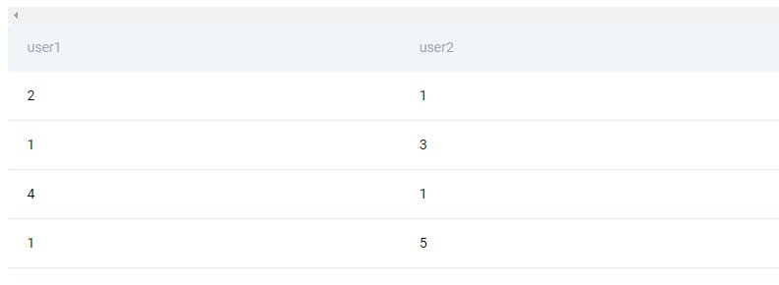

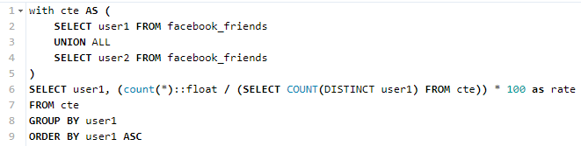

1. Используем UNION ALL, что бы объеденить обе колонки
2. После считаем отношение

**Find the date with the highest total energy consumption from the Meta/Facebook data centers. Output the date along with the total energy consumption across all data centers.**

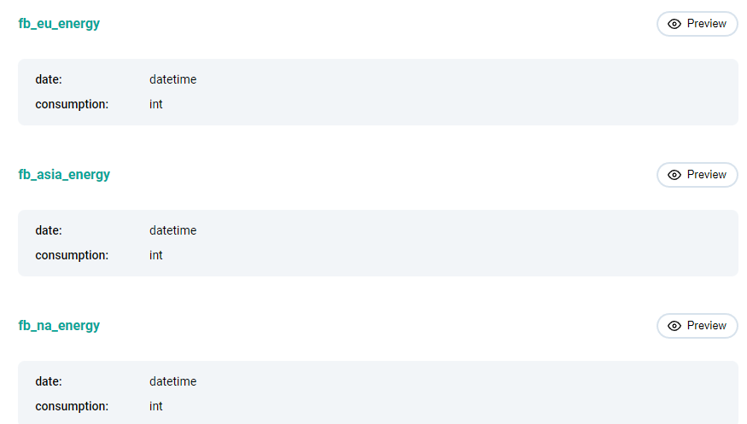

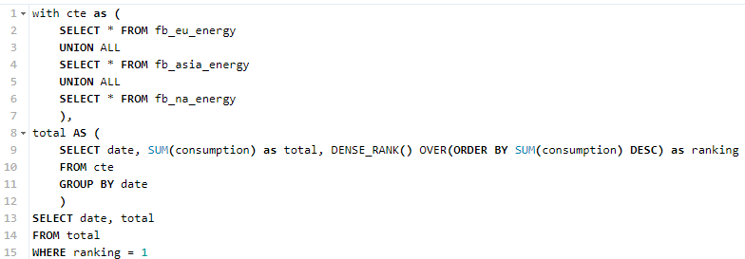

1. Объединяем данные из всех таблиц
2. Группируем по дате и ранжируем по кол-ву consumption
3. Выводим только те даты, где ранг = 1